**SE-Assignment-5:** Installation and Navigation of Visual Studio Code (VS Code)

**Name:** Faith Njuguna

Installation of VS Code

Steps to Download and Install Visual Studio Code on Windows 11

1.Visit the Download Page:

- I went to the [Visual Studio Code download page](https://code.visualstudio.com/Download).

2.Download the Installer:

- I clicked on the Windows download link to get the installer for Windows 11.

3.Run the Installer:

- I located the downloaded installer file and double-clicked to run it.

4.Follow the Setup Wizard:

- I accepted the license agreement and followed the prompts in the setup wizard.

- I chose the destination folder for the installation.

- I optionally selected additional tasks like creating a desktop icon and adding VS Code to the PATH.

5.Complete Installation:

- I clicked 'Install' and waited for the installation to complete.

- I clicked 'Finish' to launch Visual Studio Code.

Prerequisites:

- I ensured my system has Windows 11.

- I had administrative privileges to install the software.

- I had a basic understanding of the PATH environment variable if not using the default options.

First-time Setup

Initial Configurations and Settings

-After installing VS Code, I adjusted the following configurations:

1. Theme and Appearance:

- I went to File > Preferences > Color Theme.

- I selected a preferred theme from the list(the dark theme) as shown below:

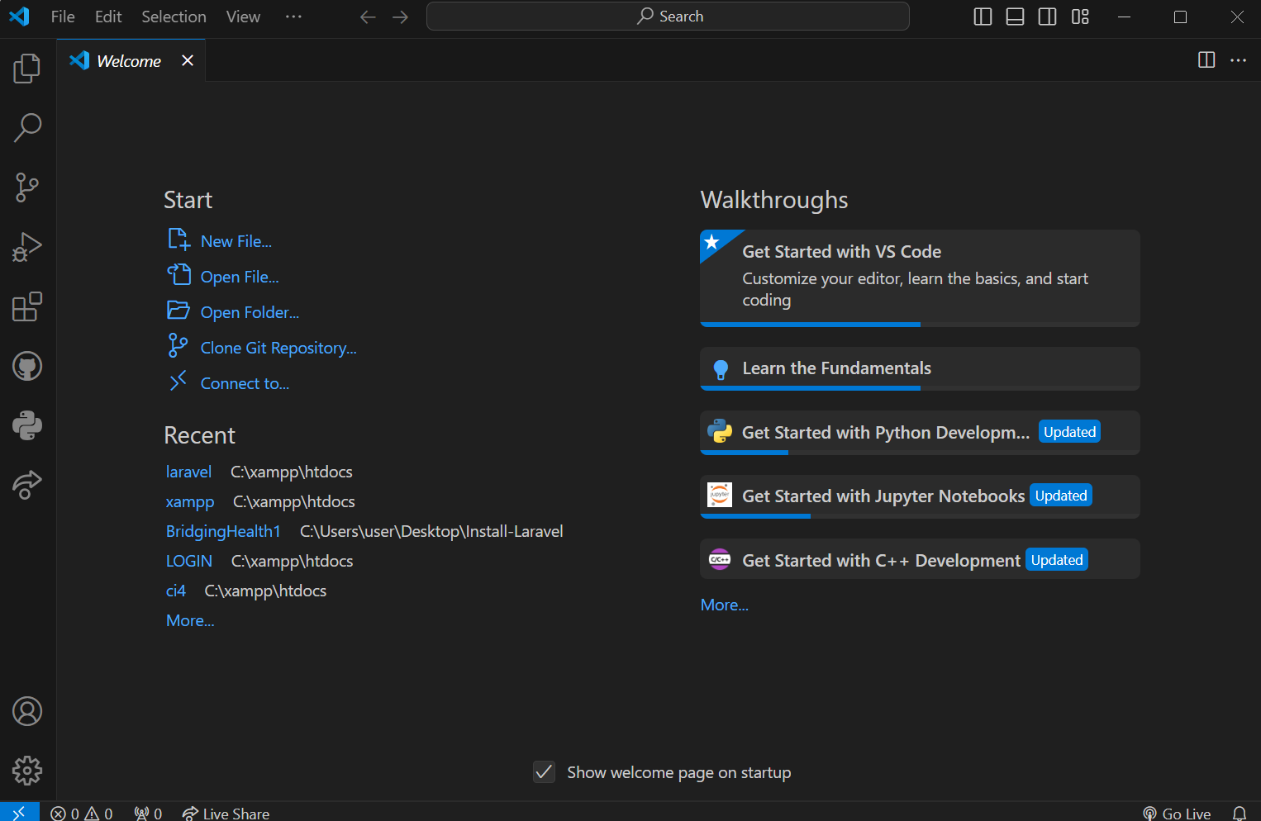

2. Settings Sync:

- I signed in with a Microsoft and GitHub account to sync settings across devices.

3. Extensions:

- I installed necessary extensions from the Extensions view (`Ctrl+Shift+X`) such as Python and Javascript.

4. Settings Configuration:

- I accessed settings via File > Preferences > Settings or `Ctrl+,`.

- I adjusted font size, line height, and other editor preferences.

User Interface Overview

Main Components of the VS Code User Interface

1. The Activity Bar:

- Located on the far left.

- Provides access to different views like Explorer, Search, Source Control, Run and Debug, and Extensions.

2. Side Bar:

- Displays the content of the selected view from the Activity Bar.

- Commonly used to navigate files and folders.

3. Editor Group:

- The main area where files are opened and edited.

- Supports multiple tabs and split views.

4. Status Bar:

- Located at the bottom.

- Displays information like line and column number, current branch in version control, and any errors or warnings.

Command Palette

- The Command Palette provides quick access to all commands in VS Code.

- I accessed it by pressing `Ctrl+Shift+P` or `F1`.

- Common tasks:

- Opening files (`Ctrl+P`).

- Running commands (`>` followed by the command name).

- Changing settings (`Preferences: Open Settings`).

Extensions in VS Code

- Extensions add functionality to VS Code, such as language support, themes, debuggers, and tools for improved productivity.

- I found, installed, and managed extensions via the Extensions view (`Ctrl+Shift+X`).

- Examples of essential extensions for web development:

- Prettier: Code formatter.

- ESLint: JavaScript and TypeScript linting.

- Live Server: Launch a local development server with live reload.

Integrated Terminal

How to Open and Use the Integrated Terminal

- I opened the integrated terminal via `Ctrl+` or View > Terminal.

- Advantages:

- Run commands directly within VS Code.

- No need to switch between the editor and an external terminal.

- Supports multiple terminal instances.

File and Folder Management

Creating, Opening, and Managing Files and Folders

-Create a New File:

- I right-clicked in the Explorer view and selected 'New File' or used `Ctrl+N`.

- Open a File or Folder:

- I used File > Open File or Open Folder, or used `Ctrl+O`.

- Navigation:

- I used Quick Open via `Ctrl+P` to jump to any file.

- I used the Explorer view for hierarchical navigation.

Settings and Preferences

Customizing Settings

- I accessed settings via File > Preferences > Settings or `Ctrl+,`.

- Examples:

- Change Theme: I used `Preferences: Color Theme` via the Command Palette.

- Font Size: I adjusted `Editor: Font Size` in the settings.

- Keybindings: I customized via `File > Preferences > Keyboard Shortcuts` or `Ctrl+K Ctrl+S`.

Debugging in VS Code

Steps to Set Up and Start Debugging

1.Open the Debug View:

- I opened it from the Activity Bar.

2. Configure Launch.json:

- I clicked on 'create a launch.json file' to configure debugging settings.

3. Set Breakpoints:

- I clicked in the gutter next to the line numbers.

4. Start Debugging:

- I clicked the green play button or pressed `F5`.

Key Debugging Features

- Breakpoints, Watch variables, Call Stack, and Debug Console.

Using Source Control

Integrating Git with VS Code

1.Initialize a Repository:

- I opened the Source Control view or used `Ctrl+Shift+G`.

- I clicked 'Initialize Repository'.

2. Making Commits:

- I staged changes by clicking the `+` icon next to the files.

- I wrote a commit message and clicked the checkmark icon to commit.

3. Pushing Changes to GitHub:

- I used the built-in terminal to add the remote repository:

git remote add origin https://github.com/Nyambura002/PLP-SE-Project

git push -u origin main

Example Extensions Installed

- Python: For Python development.

- GitLens: Enhances Git capabilities.

- Prettier: for code formatting.

Below are also examples of extensions that I have installed:

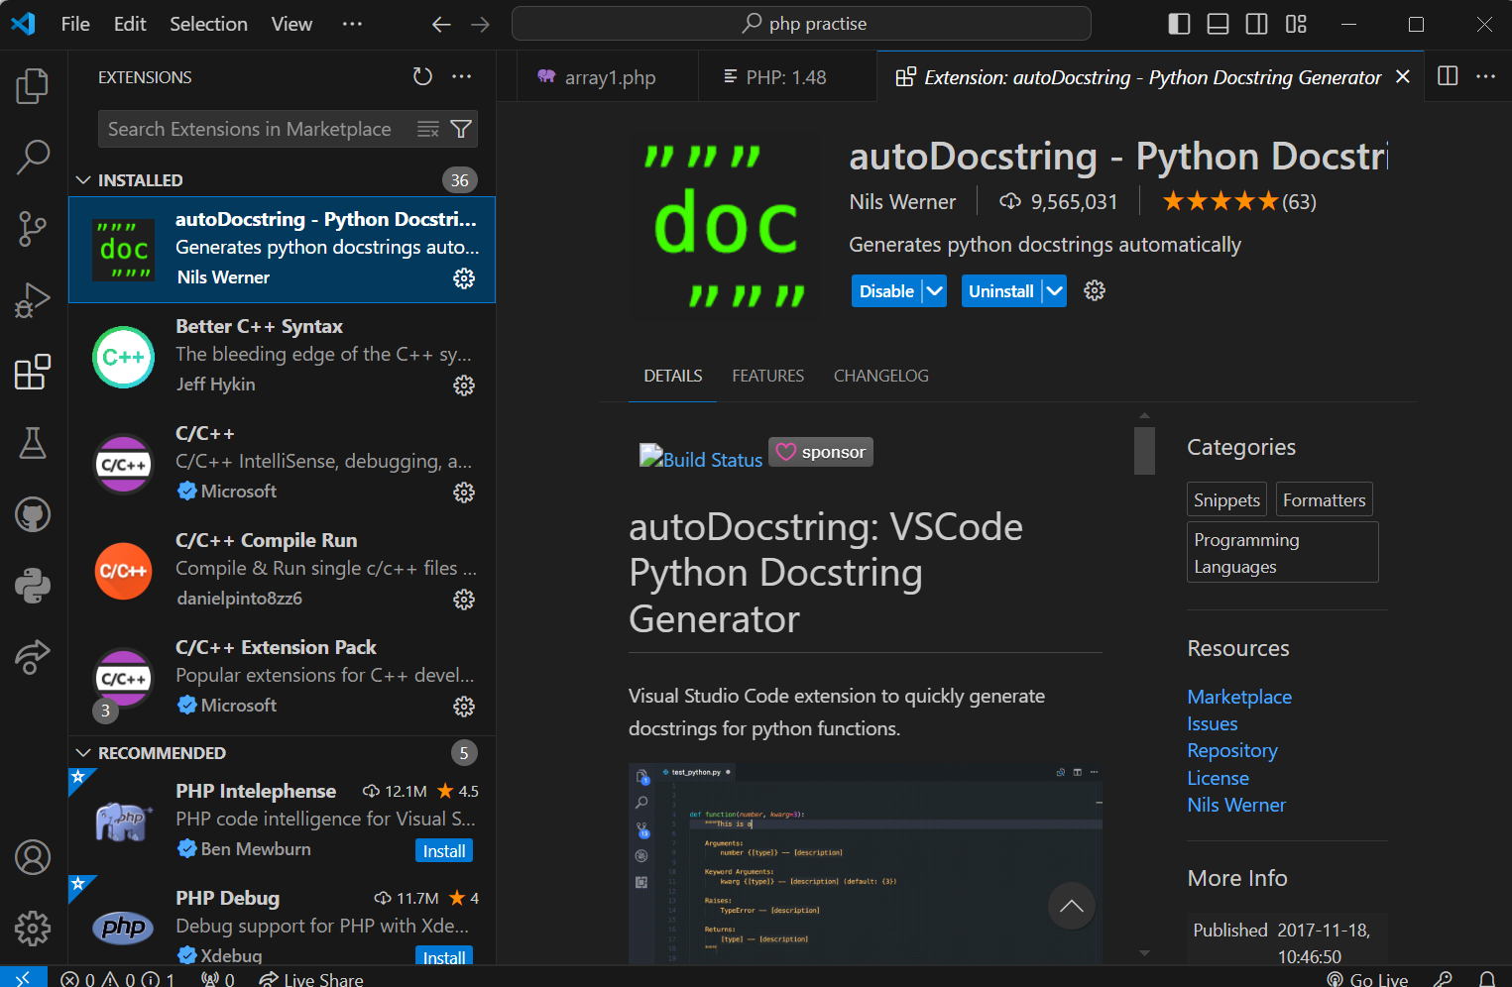

-I was able to set up and navigate Visual Studio Code effectively, covering all essential aspects from installation to the effective use of its features.

**References**

- Visual Studio Code Documentation- (https://code.visualstudio.com/docs)

- GitHub Documentation- (https://docs.github.com)